Test Case: tc001_SPX_Dev5_Crear_Solicitud_Articulo_Almacen
Step 1 - Enter username and password and click to button Enter : Credentials Entered
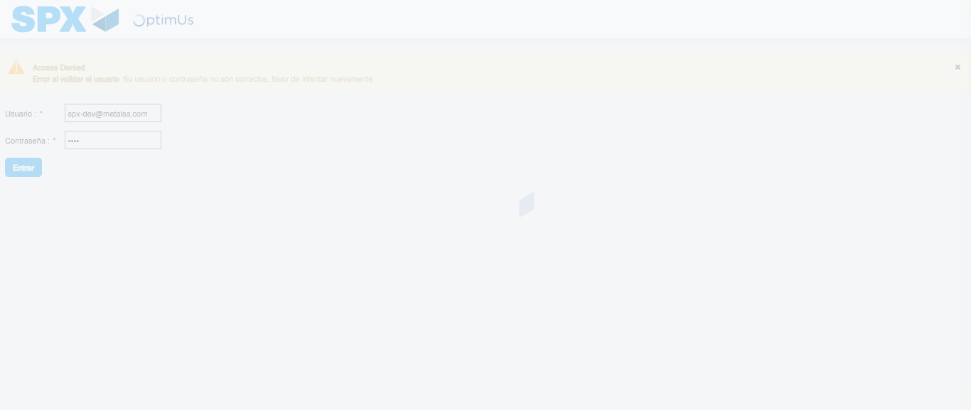Image file-name: QC_Testing-tc001_SPX_Dev5_Crear_Solicitud_Articulo_Almacen-1788280070473

Step 2 - Select to UEN and Access to Request for a New Inventory Item : UEN Correctly selected and Correct access
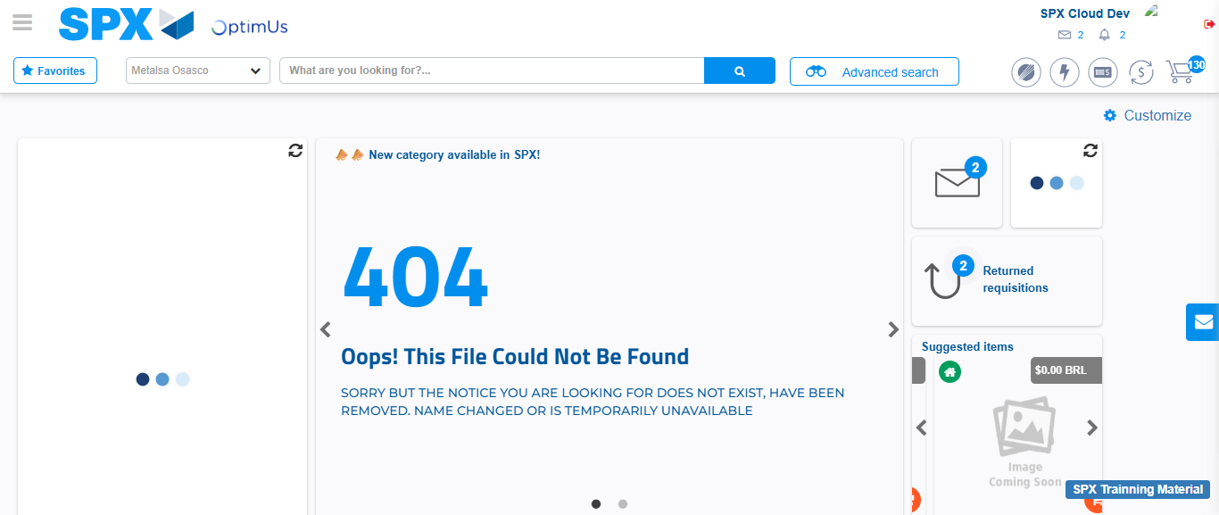Image file-name: QC_Testing-tc001_SPX_Dev5_Crear_Solicitud_Articulo_Almacen-1788280098219

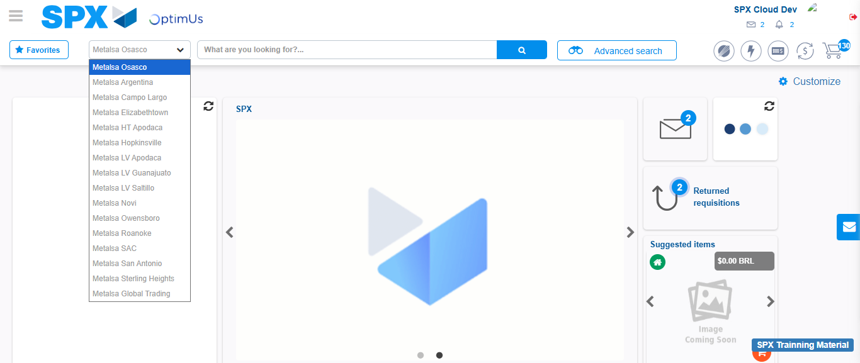Image file-name: QC_Testing-tc001_SPX_Dev5_Crear_Solicitud_Articulo_Almacen-1788280098933

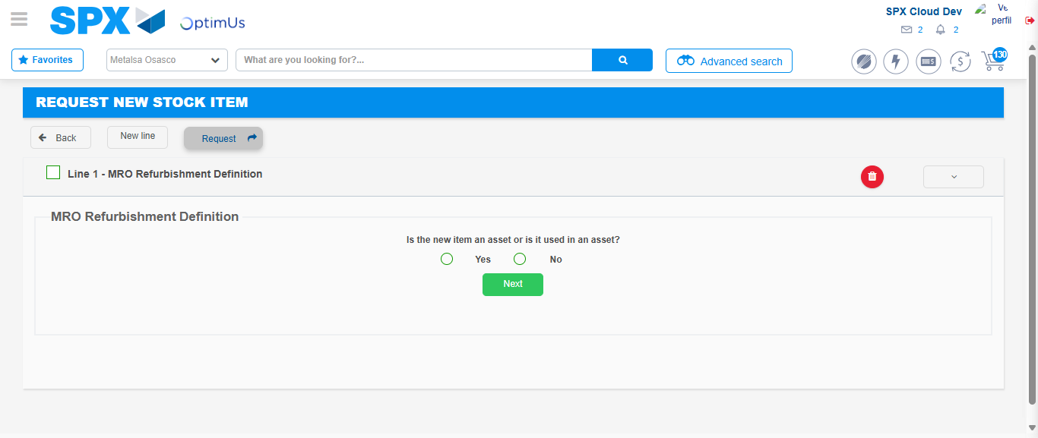Image file-name: QC_Testing-tc001_SPX_Dev5_Crear_Solicitud_Articulo_Almacen-1788280120631

Step 3 - Select options first section : Options seleted correctly
Image file-name: QC_Testing-tc001_SPX_Dev5_Crear_Solicitud_Articulo_Almacen-1788280120893

Image file-name: QC_Testing-tc001_SPX_Dev5_Crear_Solicitud_Articulo_Almacen-1788280121074

Step 4 - Select options at Screen: Options seleted correctly
Image file-name: QC_Testing-tc001_SPX_Dev5_Crear_Solicitud_Articulo_Almacen-1788280120893

Image file-name: QC_Testing-tc001_SPX_Dev5_Crear_Solicitud_Articulo_Almacen-1788280121074

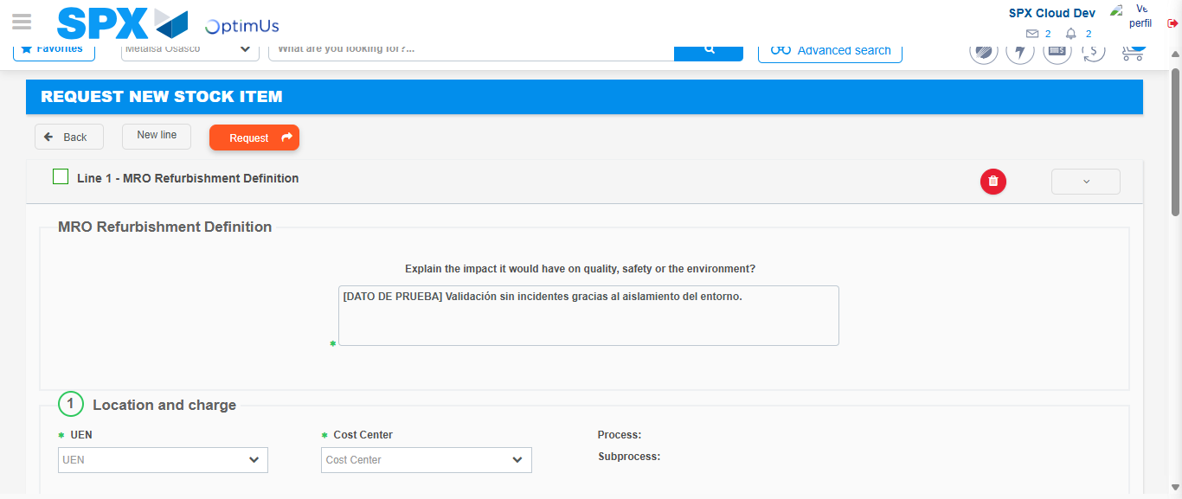Image file-name: QC_Testing-tc001_SPX_Dev5_Crear_Solicitud_Articulo_Almacen-1788280134016

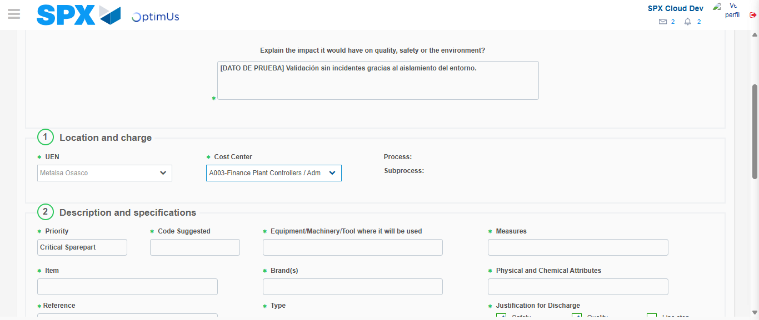Image file-name: QC_Testing-tc001_SPX_Dev5_Crear_Solicitud_Articulo_Almacen-1788280136466

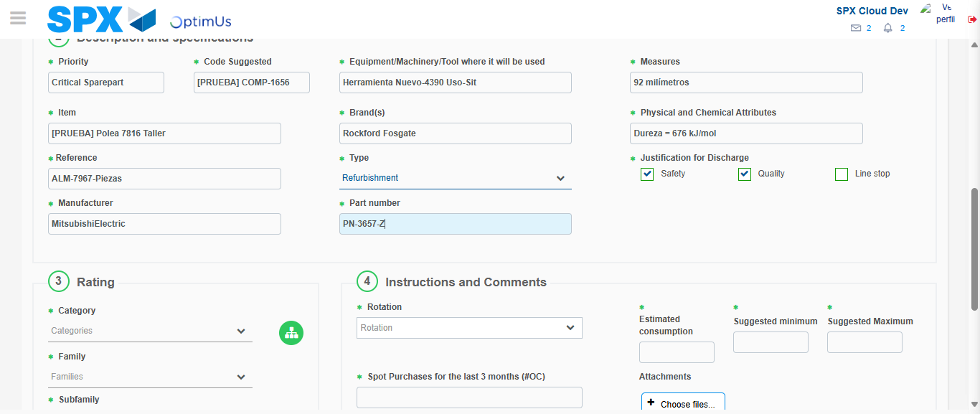Image file-name: QC_Testing-tc001_SPX_Dev5_Crear_Solicitud_Articulo_Almacen-1788280138434

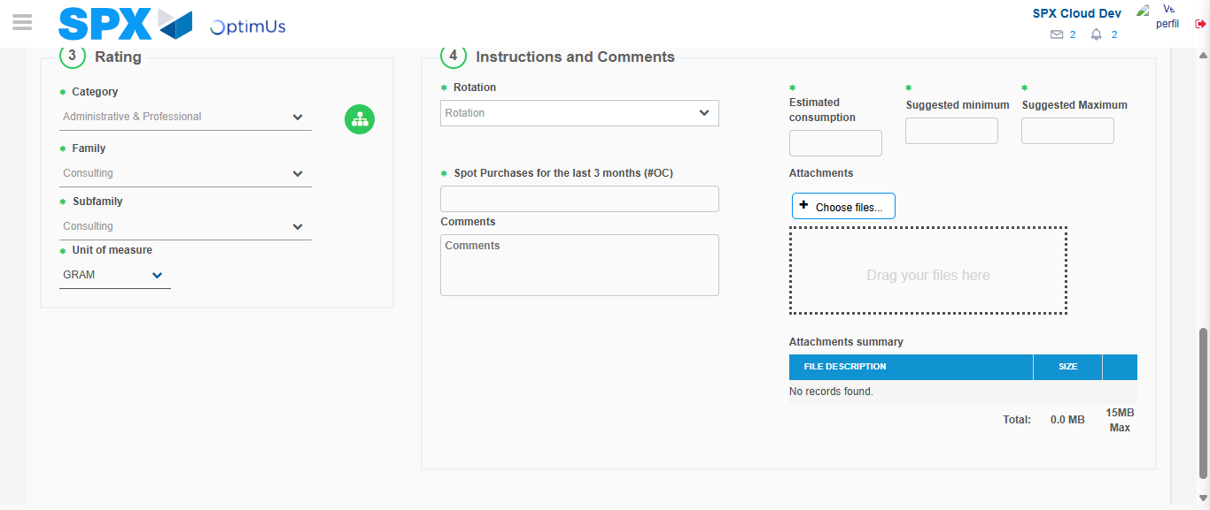Image file-name: QC_Testing-tc001_SPX_Dev5_Crear_Solicitud_Articulo_Almacen-1788280142324

Step 5 - Request New Item : Request Accepted
Image file-name: QC_Testing-tc001_SPX_Dev5_Crear_Solicitud_Articulo_Almacen-1788280098219

Image file-name: QC_Testing-tc001_SPX_Dev5_Crear_Solicitud_Articulo_Almacen-1788280098933

Image file-name: QC_Testing-tc001_SPX_Dev5_Crear_Solicitud_Articulo_Almacen-1788280120631

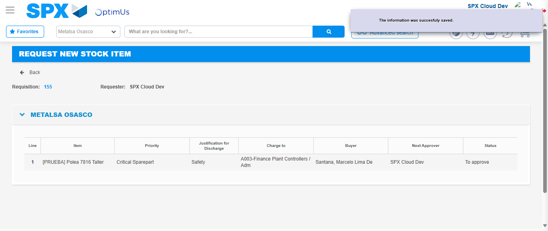Image file-name: QC_Testing-tc001_SPX_Dev5_Crear_Solicitud_Articulo_Almacen-1788280149162

Image file-name: QC_Testing-tc001_SPX_Dev5_Crear_Solicitud_Articulo_Almacen-1788280149346

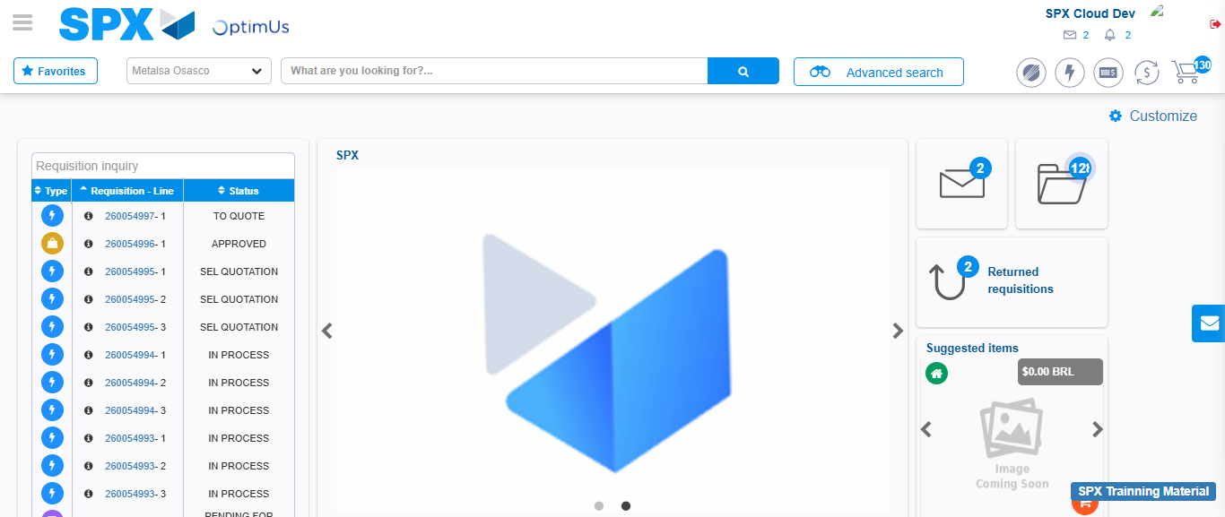Image file-name: QC_Testing-tc001_SPX_Dev5_Crear_Solicitud_Articulo_Almacen-1788280170967

Step 7 - Return to Main Page SPX : Return to Main Page SPX
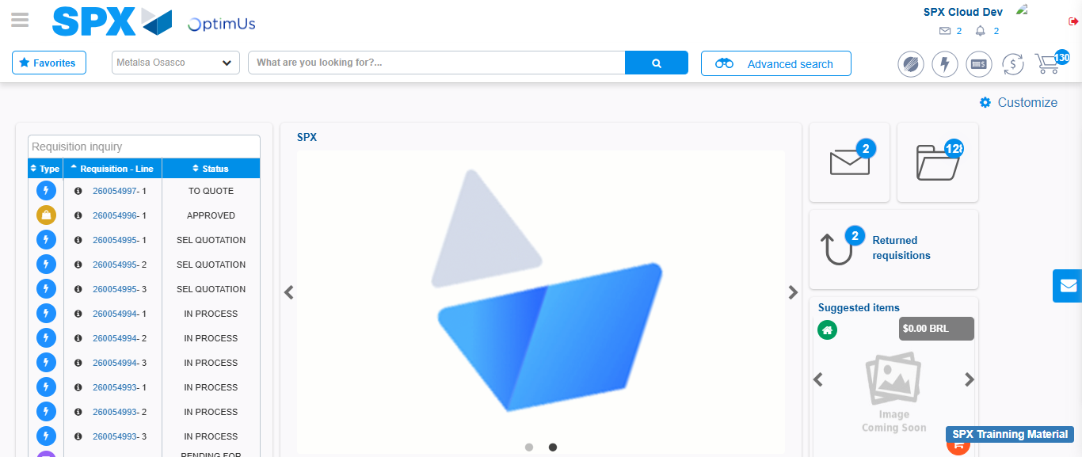Image file-name: QC_Testing-tc001_SPX_Dev5_Crear_Solicitud_Articulo_Almacen-1788280171365

